A Comprehensive Report on

Methods for Achieving Balanced Machine Learning Models

To Be Discussed:
- Validation and Cross-Validation
- Dimensionality Reduction
- Ensemble Methods
- Regularisation
- Advanced Cross-Validation Techniques

Contributed By:
Srishti – 2024UCA1923
Poorva Tehlan – 2024UCA1891
Shriya Jindal – 2024UCA1889
Kehkasha – 2024UCA1895
Iba Shibli – 2024UCA1941

1.1 Introduction
The fundamental objective of machine learning is not merely to minimize prediction error on a given training dataset, but to construct models that demonstrate consistent and reliable performance on unseen data. This objective is challenged by overfitting, a condition in which a model adapts excessively to noise and random fluctuations rather than capturing meaningful patterns.
In modern learning systems, particularly in high-dimensional environments, overfitting leads to unstable predictions and poor real-world applicability. A balanced model is one that achieves an optimal compromise between learning capacity and structural simplicity. Such models exhibit controlled variance, limited bias, and strong generalization ability. This balance is attained through systematic evaluation, feature management, model aggregation, and complexity regulation.
This report presents a detailed examination of four major techniques for building balanced machine learning models: validation through cross-validation, dimensionality reduction, ensemble learning, and regularisation.

1.2 Validation and Cross-Validation
Validation refers to the process of assessing model performance using data that is excluded from training. Its primary objective is to estimate how well a model will perform in real-world conditions. Without proper validation, performance metrics may be misleading and unreliable.
Cross-validation extends this concept by repeatedly dividing the dataset into training and testing subsets. This approach reduces dependence on a single data split and produces statistically stable estimates. It also plays a central role in hyperparameter tuning and model selection.
K-Fold Cross-Validation is the most widely used method. In this approach, the dataset is divided into k subsets. The model is trained on k−1 subsets and evaluated on the remaining subset. This process is repeated k times, and the average result is considered the final performance measure. Although computationally intensive, this method provides robust estimates of generalization error.

1.3 Dimensionality Reduction

1.3.1 Conceptual Foundations
Dimensionality reduction involves transforming high-dimensional datasets into lower-dimensional representations while preserving essential information. Many real-world datasets contain redundant or irrelevant features that increase model complexity and variance.
This phenomenon, known as the curse of dimensionality, reduces the effectiveness of distance measures and increases sample requirements. Dimensionality reduction addresses this issue by constraining the hypothesis space.

1.3.2 Mathematical and Algorithmic Methods
Principal Component Analysis (PCA) projects data onto orthogonal directions that maximize variance. Linear Discriminant Analysis (LDA) focuses on maximizing class separability. Feature selection methods identify statistically significant predictors.
Mathematically, PCA seeks directions that maximize:
Var(wᵀX)
subject to ‖w‖ = 1
These techniques improve computational efficiency and learning stability. However, excessive reduction may lead to information loss and reduced interpretability.

1.4 Ensemble Methods

1.4.1 Theoretical Motivation
Ensemble learning is based on the principle that combining multiple models can yield better predictive performance than individual learners. This improvement arises from error diversification and statistical averaging.
If individual models produce uncorrelated errors, averaging their predictions reduces variance and improves reliability.

1.4.2 Major Ensemble Paradigms
Bagging generates multiple models using bootstrap samples and aggregates their outputs. Random Forests represent a prominent example.
Boosting trains models sequentially, assigning higher weights to misclassified instances. Algorithms such as AdaBoost and Gradient Boosting follow this approach.
Stacking integrates heterogeneous models using a meta-learner that learns optimal combinations.

1.4.3 Performance Characteristics
Ensemble methods consistently outperform single models in complex environments. However, they require substantial computational resources and often lack interpretability.

1.5 Regularisation

1.5.1 Mathematical Framework
Regularisation introduces a penalty term into the learning objective to restrict model complexity. The generalized loss function is expressed as:
L(β) = Σ (yᵢ − ŷᵢ)² + λP(β)
where λ ≥ 0 is the regularisation parameter and P(β) represents the penalty term.
This formulation discourages large coefficient values and stabilizes learning.

1.5.2 Norm-Based Regularisation
L2 regularisation (Ridge) uses:
P(β) = Σ βⱼ²
L1 regularisation (Lasso) uses:
P(β) = Σ |βⱼ|
Elastic Net combines both penalties:
P(β) = α Σ |βⱼ| + (1 − α) Σ βⱼ²
L2 regularisation induces continuous shrinkage, L1 promotes sparsity, and Elastic Net balances both effects.

1.5.3 Impact on Generalization
Regularisation reduces variance, improves numerical stability, and prevents overfitting. However, excessive regularisation may increase bias and reduce predictive accuracy.

1.6 Advanced Cross-Validation Techniques
Cross-validation is a fundamental tool for evaluating the generalization ability of machine learning models. While basic K-Fold Cross-Validation is suitable for many applications, complex data structures, imbalanced classes, temporal dependencies, and extensive hyperparameter tuning require specialized validation strategies. Advanced cross-validation techniques are designed to address these challenges and provide unbiased, reliable performance estimates.
These methods improve model selection, reduce evaluation bias, and ensure realistic testing conditions.

1.6.1 Stratified K-Fold Cross-Validation
Stratified K-Fold Cross-Validation is used mainly for classification problems involving imbalanced class distributions. In standard K-Fold methods, some folds may contain very few minority-class samples, leading to unreliable evaluation.
Stratified K-Fold preserves the original class proportions in each fold, ensuring that every subset is representative of the overall dataset.

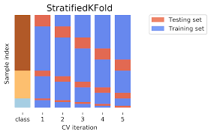

Advantages -Maintains class balance, improves evaluation accuracy

Disadvantages -Limited to classification, complex for regression

1.6.2 Leave-One-Out Cross-Validation (LOOCV)
Leave-One-Out Cross-Validation uses a single data point for testing and the remaining data for training. This process is repeated for each observation.
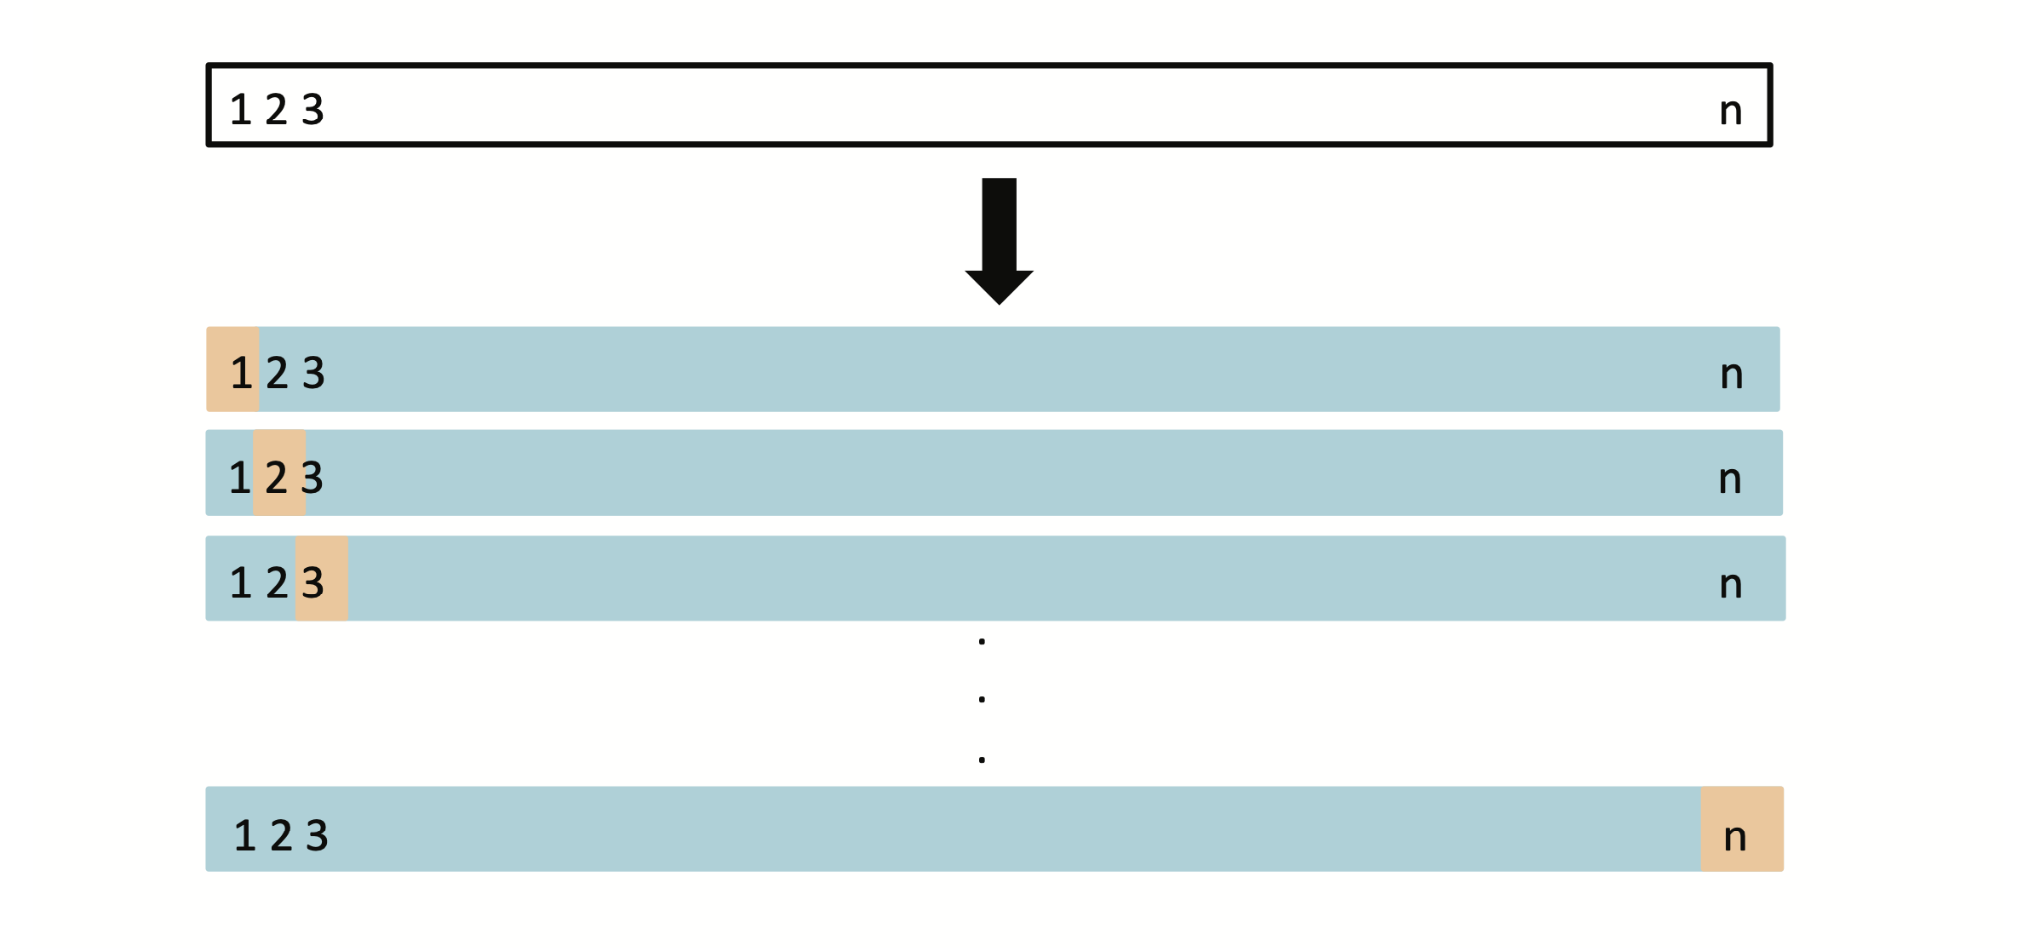

Advantages - Maximum data usage, low bias

Disadvantages - Very high computation, high variance

1.6.3 Time Series Cross-Validation
Time series data has temporal dependencies. Random splitting destroys this structure and causes data leakage. Time Series Cross-Validation preserves chronological order.
A common method is the rolling window approach.
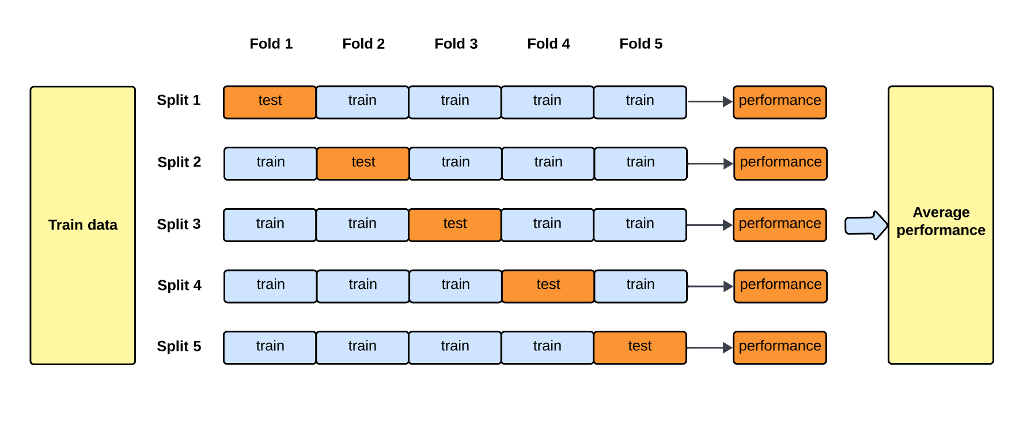

Advantages - Prevents data leakage, realistic forecasting
Disadvantages - Limited early training data

1.6.4 Monte Carlo Cross-Validation (Shuffle Split)
Monte Carlo Cross-Validation randomly splits the dataset multiple times into training and testing sets. Each split is independent.
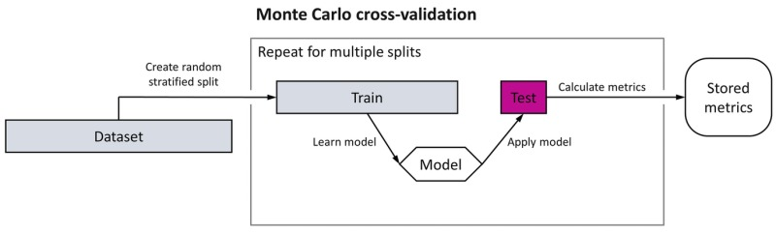

Data points may appear multiple times or not at all.

Advantages- Flexible, scalable

Disadvantages- Uneven coverage, unstable results

1.6.5 Nested Cross-Validation
Nested Cross-Validation is used for unbiased hyperparameter tuning and performance evaluation. It uses two loops: an outer loop for testing and an inner loop for tuning.
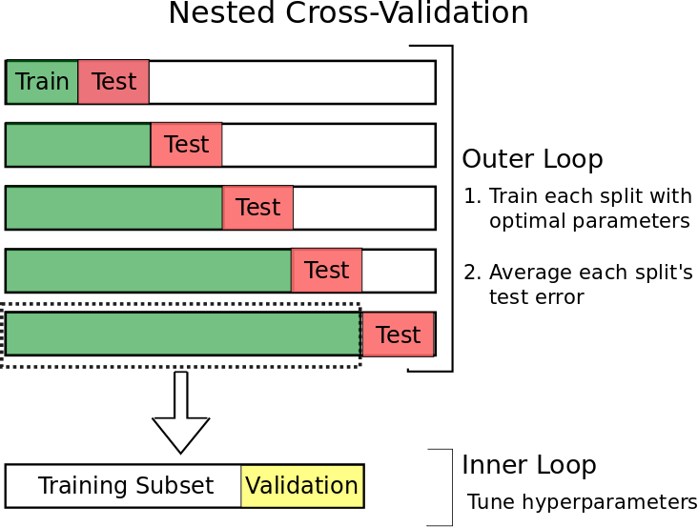
The outer loop evaluates final performance, while the inner loop selects hyperparameters.

Advantages - Eliminates selection bias, high reliability

Disadvantages- Extremely computationally expensive

1.6.6 Comparative Summary of Advanced Cross-Validation Techniques

Table: Comparison of Cross-Validation Methods
Method | Main Purpose | Best Use Case | Advantages | Disadvantages
Stratified K-Fold | Maintain class balance | Imbalanced classification | Fair evaluation | Not for regression
LOOCV | Maximize data usage | Small datasets | Low bias | Very slow
Time Series CV | Preserve time order | Forecasting | No leakage | Limited early data
Monte Carlo CV | Random resampling | Large datasets | Flexible | Unstable
Nested CV | Unbiased model selection | Research benchmarking | Highly reliable | High cost

1.6.7 Interpretation and Practical Selection
The choice of cross-validation method depends on dataset structure, problem type, and available computational resources. Stratified K-Fold is preferred for imbalanced classification. LOOCV is suitable for small datasets. Time Series Cross-Validation is essential for temporal data. Monte Carlo methods offer flexibility for large datasets. Nested Cross-Validation is recommended for rigorous research evaluation.
Selecting an appropriate validation strategy ensures that model performance estimates are accurate, unbiased, and representative of real-world behavior.

1.7 Integrated Perspective on Model Balance
Balanced model construction requires coordinated application of validation, dimensionality reduction, ensemble learning, and regularisation. Validation ensures reliable evaluation. Dimensionality reduction controls hypothesis space. Ensembles mitigate individual weaknesses. Regularisation stabilizes parameters.
Together, these techniques implement structural risk minimization and prevent over-reliance on limited training data.

1.8 Conclusion
The development of balanced machine learning models is essential for reliable and generalizable prediction. Validation frameworks provide dependable performance estimates. Dimensionality reduction alleviates high-dimensional instability. Ensemble methods enhance predictive power. Regularisation enforces structural discipline.
These approaches collectively shift learning from empirical optimization toward principled generalization. As machine learning systems grow in scale and complexity, their integration will remain fundamental to maintaining predictive integrity and robustness.

1.9 References
- Hastie, T., Tibshirani, R., & Friedman, J. (2009). The Elements of Statistical Learning. Springer.
- Bishop, C. M. (2006). Pattern Recognition and Machine Learning. Springer.
- IBM. What Is Regularization?
https://www.ibm.com/think/topics/regularization
- DataCamp. Ridge, Lasso & Elastic Net Regression.
https://www.datacamp.com/tutorial/tutorial-ridge-lasso-elastic-net
- Zou, H., & Hastie, T. (2005). Regularization and Variable Selection via Elastic Net. Journal of the Royal Statistical Society.
- Medium. Understanding Bias–Variance Tradeoff.
https://medium.com/@lomashbhuva/understanding-the-bias-variance-tradeoff-and-regularization
- Scikit-Learn Documentation. Model Evaluation and Validation.
https://scikit-learn.org/stable/modules/cross_validation.html

